**Data to be used in Capstone Project**

As it was described previously in the business problem, location of a restaurant and how unique the food is will determine the success of a new business in the industry of food services. Therefore, I will consider the current location of restaurants in Downtown Guadalajara, where most of the tourists visit to get a sense of the mexican culture.

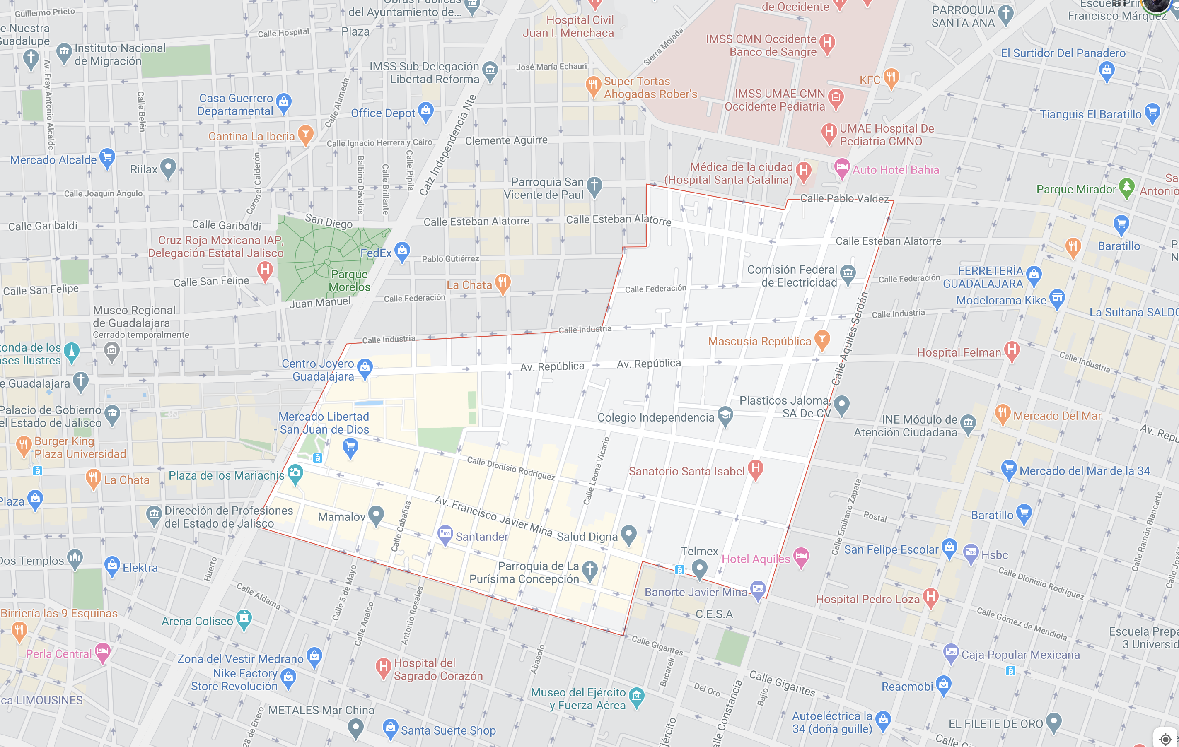

In order to propose a suitable and convenient location, this project will use data from Foursquare to locate two types of places for eating out: Restaurants and Fondas. People often wonder what a ‘Fonda’ is. The word, Arabic in origin, is defined by the dictionary as “a tavern, inn or small restaurant.” But like the European concepts *bistro* and*tratttoria*, the definition here in Mexico has become blurred, or better said, broadened. There are fancy restaurants like the recently closed but legendary**Fonda del Refugio**, an elegant townhouse staffed by bow-tied waiters and tables set with white tablecloths and nice china. There's postmodern [**Fonda Fina**](https://www.goodfoodmexico.com/home/fine-dining-fonda-fina) in Mexico or Brooklyn’s [**Fonda**](http://fondarestaurant.com/), a small, very New Yorky place offering interesting modern re-workings of classic dishes and good tequila. But ‘real’ fondas, in the old-fashioned sense are small mom-and-pop joints with just a few tables; simple unpretentious eateries serving breakfast, snacks or an inexpensive ‘comida corrida’ - lunch served in three ‘tiempos’ or courses. In Mexico fondas are in every downtown and market. Here in Guadalajara, the best are located in our historic center.

An important feature for a right location will be to stay close enough to downton, at a walkable distance. Therefore, we will use the K-means machine learning algorithm to determine which clusters (according to location) are available in this part of the city. The idea would be to establish a restaurant or fonda (depending on current offer) in the cluster with the greatest amount of options. At the same time, we will identify which type of food is not currently being prepared for visitors, so they can have one additional true alternative at reasonable prices.